TOK
Okay… how to get started?
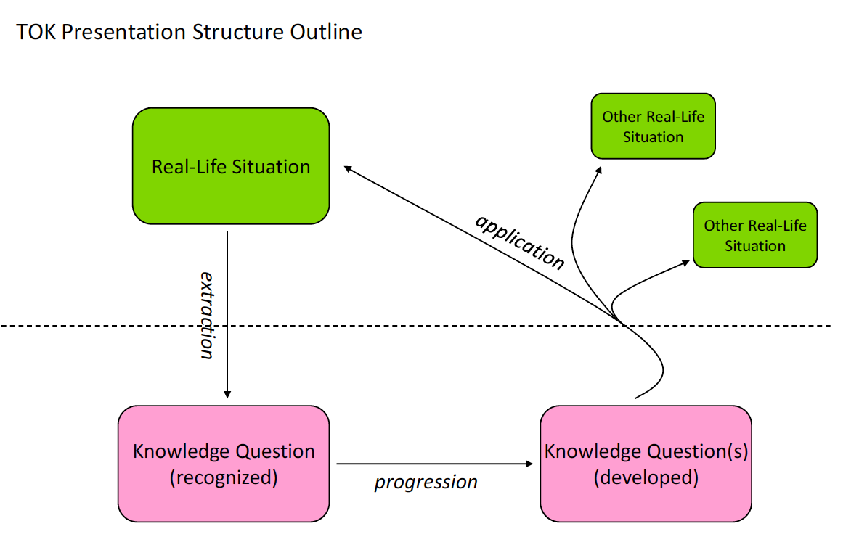

EXAMPLE 1:

Real-life Situation: Egyptian government attack and kill civilians.
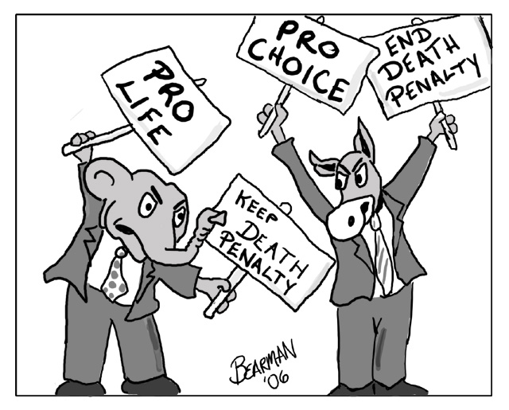
Knowledge Question: To what extent can we justify the killing of another human being?

Other real life situations and knowledge questions…

EXAMPLE 2:
My uncle went to an acupuncturist.
What is it about a scientific explanation that makes it convincing or unconvincing?

EXAMPLE 3:
An optical illusion.
What if anything, do optical illusions tell us about sense perception and truth?

EXAMPLE 4:
A book: The Execution of Saddam Hussein.
What role should intuition play in justifying capital punishment?

EXAMPLE 5:
A move to make history a compulsory school subject up to age 16.
To what extent should academic disciplines be ranked according to their usefulness?

EXAMPLE 6:
The connection between being a smoker and one’s parents being smokers.
How does a scientific explanation distinguish between correlation and causation?

EXAMPLE 7:
Iran’s president calls for a conference to establish whether the Jewish Holocaust really happened.
How can we draw a clear line between fact and interpretation in history?

EXAMPLE 8:
The use of a personality test to assess students in the class.
What are the strengths and limitations of quantification in the human sciences?

EXAMPLE 9:
The death of Bogon—the last speaker of the Kasabe language in Cameroon.
In what ways does language affect how we interpret the world?

EXAMPLE 10:
Demonstrations in China against a Japanese textbook.
Who should decide what history is taught in schools?

EXAMPLE 11:
An article on science and religion.
How can reason be used to justify religious beliefs?

EXAMPLE 12:
The case of pulling the plug on a hospital patient in a vegetative state.
What should the role of emotion be in the justification of ethical decisions?

EXAMPLE 13:
A politician argues for higher taxes for the rich.
How can we distinguish between valid and invalid deductive arguments?

Knowledge Questions and your articles…!

RLS = Real Life Situation
KQ = Knowledge Question

RLS = Daily Telegraph article claiming that in Egypt…..
KQ = ?

RLS = can you use your news article that you gave to me to establish a real life situation?

KQ = ?
Knowledge Questions:

A

B

C

D

E
^{2…} these are taken to be the Areas of Knowledge, the Ways of Knowing, and the concepts in the linking questions: beliefs, certainty, culture, evidence, experience, explanation, interpretation, intuition, justification, truth and values.
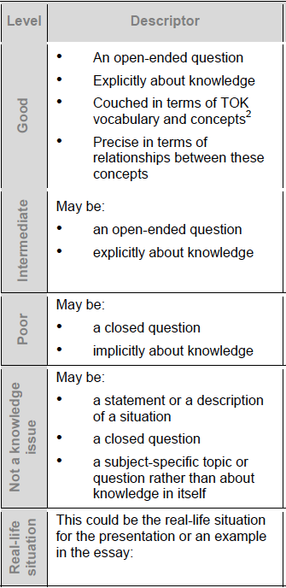

Knowledge Questions:

Remember your knowledge question is crucial to good TOK!

Knowledge

Question
Notes:
About knowledge

Open question

general

